An Asset Management System
21CSC205P Database Management Systems
A MINI PROJECT REPORT

Submitted by

Shradha Kumar Reddy Vitta [RA2411026010445]
Harsh Bubna [RA2411026010466]

Under the Guidance of

Ms. Sasi Rekha Sankar

(Assistant Professor, Department of Computational Intelligence)

in partial fulfillment of the requirements for the degree of

BACHELOR OF TECHNOLOGY

in

COMPUTER SCIENCE ENGINEERING

with specialization in (Artificial Intelligence and Machine Learning)


DEPARTMENT OF NETWROKING AND COMMUNICATIONS

SCHOOL OF COMPUTING

COLLEGE OF ENGINEERING AND TECHNOLOGY
SRM INSTITUTE OF SCIENCE AND TECHNOLOGY

KATTANKULATHUR- 603 203

MAY 2026



SRM INSTITUTE OF SCIENCE AND TECHNOLOGY

KATTANKULATHUR – 603 203

BONAFIDE CERTIFICATE

Certified that Project report titled “Asset Management System” is the Bonafide work of “Shradha Kumar Reddy Vitta [RA2411026010445], Harsh Bubna [RA2411026010466]” who carried out the 21CSC205P Database Management Systems mini project work under my supervision.

COURSE FACULTY | HEAD OF THE DEPARMENT
DESIGNATION  Department | PROFESSOR AND HEAD  Department

ABSTRACT
The proposed Asset Management System aims to provide a structured and efficient approach to managing stock, suppliers, customers, and transactions within an organization. The project focuses on designing a database-centric solution that will enable businesses to monitor Asset levels, reduce manual errors, and improve operational efficiency.

At its current stage, the project primarily concentrates on database design concepts such as Entity–Relationship modeling, relational schema creation, normalization techniques, and SQL query planning. The implementation phase involving database creation and front-end integration is planned for future development.

This mini-project demonstrates the theoretical and structural foundation required for building a scalable Asset management application using Database Management System principles.

TABLE OF CONTENTS

Chapter No. | Title | Page no.
 | ABSTRACT
1 | Problem understanding, Identification of Entity and Relationships, Construction of DB using ER Model for their project
2 | Design of Relational Schemas, Creation of Database and Tables for their project
3 | 3.1Writing queries based on the concepts of Aggregate functions, constraints, sets
 | 3.2 Writing complex queries based on subqueries, joins and views
 | 3.3 Writing complex queries based on the concepts of functions, Triggers, Cursors and Exception Handling
4 | 4.1 Analysing the pitfalls, identifying the dependencies, and applying Normalizations- 1NF, 2NF, 3NF
 | 4.2 Analysing the pitfalls, identifying the dependencies, and applying Normalizations- 4NF, 5NF
5 | Implementation of concurrency control and recovery mechanisms.
6 | Front-end And Back-End Implementation code
7 | Results and Discussions

LIST OF FIGURES

Figure No. | Name | Page no.
2.1 | Relational Schema for Asset management System | 12
2
3
4
5

LIST OF TABLES

Figure No. | Name | Page no.
2.1 | Admin Table | 12
2.4.1 | Supplier Table | 16
2.4.2 | Item Table | 17
2.4.3 | StockDetail Table | 17

CHAPTER 1

PROBLEM UNDERSTANDING, IDENTIFICATION OF ENTITY AND RELATIONSHIPS, CONSTRUCTION OF DB USING ER MODEL FOR THE ASSET MANAGEMENT SYSTEM

  - Introduction
Asset management plays a crucial role in the smooth functioning of organizations that deal with physical goods, products, or raw materials. Efficient Asset control ensures that the right quantity of items is available at the right time, thereby preventing losses caused by overstocking, understocking, or mismanagement. Traditionally, many small and medium-scale businesses rely on manual record-keeping methods such as notebooks or spreadsheets, which are highly prone to human error, data duplication, and data loss.
The proposed Asset Management System aims to introduce a structured and database-oriented approach to managing Asset information digitally. Instead of relying on scattered or unorganized records, the system will centralize all product, supplier, and transaction data into a unified database environment. This will allow for faster data retrieval, better organization, and improved decision-making.
At the current stage, the project primarily focuses on conceptual design and database planning. The emphasis is placed on understanding the theoretical aspects of Database Management Systems (DBMS) such as Entity-Relationship modeling, schema design, normalization, and SQL query structuring. The actual software implementation and deployment are planned for future development phases. The project therefore acts as a foundational framework that demonstrates how Asset systems can be efficiently built using structured database principles

  - Motivation
The motivation behind developing the proposed Asset Management System arises from both academic learning objectives and real-world business needs. In an academic context, the project provides an opportunity to apply theoretical DBMS concepts into a practical scenario, thereby bridging the gap between textbook knowledge and real-world application.
From an industry perspective, businesses often struggle with inefficient stock management due to outdated or manual systems. Such systems can lead to frequent stock mismatches, delayed order processing, and inaccurate financial tracking. By designing a digital Asset system, these issues can be minimized significantly.
Another strong motivating factor is the growing reliance on technology-driven solutions in modern enterprises. Learning to design database systems prepares students for careers in software development, data management, and enterprise application development. The project also encourages problem-solving skills, logical thinking, and systematic data organization.
Additionally, the motivation includes gaining hands-on exposure to SQL query planning, understanding normalization techniques, and analyzing transaction control mechanisms. These skills are essential for anyone pursuing a career in Computer Science, especially in domains involving data analytics, backend development, or enterprise software engineering.
  - Scope
The scope of the proposed Asset Management System currently lies within the design and conceptual planning phase rather than full-scale implementation. The project primarily focuses on identifying core system components and defining how they will interact within a database environment. The design scope includes entity identification, ER diagram development, relational schema formulation, and SQL query structuring.
Within this scope, the system is intended to support features such as product record maintenance, supplier management, customer tracking, and order history storage. These features are explored from a theoretical and structural standpoint to ensure that the final design is scalable and adaptable for future expansion.
The future scope of the project extends toward complete implementation involving database creation, user interface development, and system deployment. Potential enhancements may include real-time analytics, barcode scanning integration, cloud database hosting, and automated reporting features. The system could also be expanded to include multi-branch Asset synchronization, mobile application interfaces, and AI-based demand prediction models.
Thus, while the present project focuses on structural design, its future scope holds potential for transformation into a fully functional enterprise-level Asset management application.
  - Problem Statement
Many organizations, particularly small and medium enterprises, face significant challenges in maintaining accurate and up-to-date Asset records. Manual tracking systems or poorly structured digital records often result in inconsistencies such as duplicate entries, missing data, incorrect stock counts, and delayed updates. These inefficiencies can lead to financial losses, reduced customer satisfaction, and operational disruptions.
The primary problem addressed in this project is the absence of a structured and reliable database system that can efficiently manage Asset-related data. Without a proper database framework, businesses struggle to monitor product availability, manage supplier relationships, and track customer orders accurately.
This project aims to propose a systematic database design that will serve as a blueprint for a future Asset management application. By focusing on entity relationships, schema structuring, and normalization techniques, the project seeks to eliminate redundancy, ensure data integrity, and provide a strong foundation for digital Asset management. The goal is to develop a scalable and efficient database architecture that can later be implemented into a functional software solution.

  - Project Requirements
Functional Requirements (Proposed)
The functional requirements describe the essential operations that the system is expected to perform once implemented. These include the ability to add, update, and delete product records; manage supplier and customer information; record purchase and sales transactions; and maintain real-time stock levels. The system is also expected to support query-based data retrieval and reporting features. Additionally, the system should allow administrators to monitor Asset flow, generate summaries of stock movement, and identify low-stock alerts. These features ensure that users can interact with the database efficiently and perform daily Asset tasks without complexity.
Non-Functional Requirements (Proposed)
Non-functional requirements focus on system performance and quality attributes. The system should ensure data accuracy, reliability, and security to prevent unauthorized access or data corruption. Scalability is another important factor, as the database should be capable of handling increasing volumes of data over time. Performance efficiency is also crucial so that queries and updates occur with minimal delay. The user interface, once developed, should be intuitive and user-friendly, enabling individuals with limited technical expertise to operate the system effectively. Together, these requirements aim to create a robust and dependable Asset management framework.
  - Identification of Entity and Relationships
Entity identification is a fundamental step in database design, as it determines the primary objects or components around which the database will be structured. In the proposed Asset Management System, several core entities have been identified based on real-world Asset operations. These include Product, Supplier, Customer, Order, Asset, and Administrator/Employee.
Each entity represents a distinct data category with specific attributes. For instance, the Product entity may include attributes such as Product ID, Name, Category, Price, and Quantity. The Supplier entity may contain Supplier ID, Contact Details, and Address information. Similarly, Customer and Order entities capture transaction-related data. The relationships among these entities define how they interact with one another. A Supplier supplies Products, a Customer places Orders, and Orders contain multiple Products. The Asset entity stores and monitors stock levels, while the Administrator manages system updates. Identifying these relationships ensures that the database structure reflects real-world processes accurately and supports logical data flow.
  - Construction of DB Using ER Model for the Asset Management System
The Entity–Relationship (ER) Model serves as a visual and conceptual representation of how data entities and their relationships are organized within a database. For the proposed Asset Management System, the ER model will act as a blueprint that guides the entire database design process.
In the ER diagram, entities will be represented as rectangles, attributes as ovals, and relationships as diamonds. Primary keys will be highlighted to uniquely identify records, while foreign keys will establish links between related tables. Cardinality ratios such as one-to-one, one-to-many, and many-to-many relationships will be defined to illustrate how entities interact.
Constructing the ER model before actual database creation helps in identifying potential design flaws, reducing redundancy, and ensuring data consistency. It also provides a clear roadmap for relational schema generation and SQL table creation in later stages. Although the database is not yet implemented, the ER model forms the foundational design structure that will support future development and integration phases.

Chapter 2
Design of Relational Schemas, Creation of Database and Tables for Asset Management System

2.1 Relational Schema for Asset Management System
Admin (AdminID, FirstName, MiddleName, LastName, Email, Password)
Supplier (SupplierID, SupplierName, ContactInfo)
Item (ItemID, ItemName, Category, SupplierID)
StockDetail (StockID, ItemID, BatchNo, ExpiryDate, Quantity)
Orders (OrderID, OrderDate, Status, TotalAmount)
OrderItem (OrderItemID, OrderID, ItemID, Quantity, Price)
Sale (SaleID, SaleDate, TotalAmount)
SaleItem (SaleItemID, SaleID, ItemID, SoldQty, SellingPrice)
Analytics (AnalyticsID, SaleID, Profit, Loss)

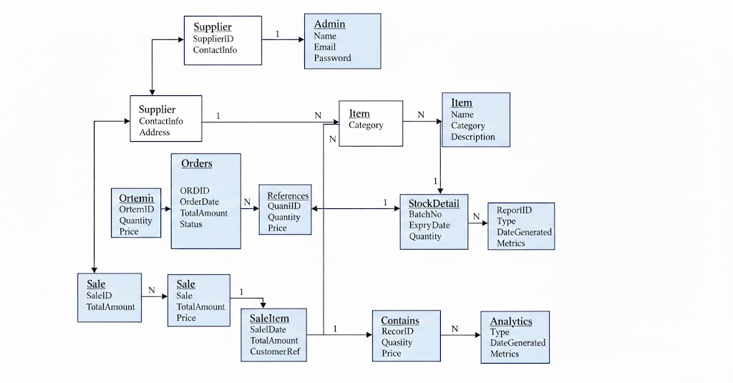
Figure 2.1: Relational Schema for Asset management System
The figure 2.1 represents the conceptual structure of the Asset Management System, showing entities such as Admin, Item, Supplier, Stock, Orders, Sales, and Analytics. It illustrates relationships and attributes required for database design.
2.2 Description of Tables
Attribute | Data Type | Size | Constraint
AdminID | INT | – | PRIMARY KEY
FirstName | VARCHAR | 30 | NOT NULL
MiddleName | VARCHAR | 30 | –
LastName | VARCHAR | 30 | NOT NULL
Email | VARCHAR | 50 | UNIQUE
Password | VARCHAR | 50 | NOT NULL
Table 2.1: Admin Table
2.3 Creation of Database and Tables - DDL Commands
DDL Commands to create all the tables.
CREATE DATABASE AssetManagement;
USE AssetManagement;

CREATE TABLE Admin(
AdminID INT PRIMARY KEY,
FirstName VARCHAR(30),
MiddleName VARCHAR(30),
LastName VARCHAR(30),
Email VARCHAR(50) UNIQUE,
Password VARCHAR(50)
);

CREATE TABLE Supplier(
SupplierID INT PRIMARY KEY,
SupplierName VARCHAR(50),
ContactInfo VARCHAR(100)
);

CREATE TABLE Item(
ItemID INT PRIMARY KEY,
ItemName VARCHAR(50),
Category VARCHAR(30),
SupplierID INT,
FOREIGN KEY (SupplierID) REFERENCES Supplier(SupplierID)
);

CREATE TABLE StockDetail(
StockID INT PRIMARY KEY,
ItemID INT,
BatchNo VARCHAR(20),
ExpiryDate DATE,
Quantity INT CHECK (Quantity >= 0),
FOREIGN KEY (ItemID) REFERENCES Item(ItemID)
);

CREATE TABLE Orders(
OrderID INT PRIMARY KEY,
OrderDate DATE,
Status VARCHAR(20),
TotalAmount DECIMAL(10,2)
);

CREATE TABLE OrderItem(
OrderItemID INT PRIMARY KEY,
OrderID INT,
ItemID INT,
Quantity INT,
Price DECIMAL(10,2),
FOREIGN KEY (OrderID) REFERENCES Orders(OrderID),
FOREIGN KEY (ItemID) REFERENCES Item(ItemID)
);

CREATE TABLE Sale(
SaleID INT PRIMARY KEY,
SaleDate DATE,
TotalAmount DECIMAL(10,2)
);

CREATE TABLE SaleItem(
SaleItemID INT PRIMARY KEY,
SaleID INT,
ItemID INT,
SoldQty INT,
SellingPrice DECIMAL(10,2),
FOREIGN KEY (SaleID) REFERENCES Sale(SaleID),
FOREIGN KEY (ItemID) REFERENCES Item(ItemID)
);

CREATE TABLE Analytics(
AnalyticsID INT PRIMARY KEY,
SaleID INT,
Profit DECIMAL(10,2),
Loss DECIMAL(10,2),
FOREIGN KEY (SaleID) REFERENCES Sale(SaleID)
);
2.4 Insertion of tuples into the table – DML commands
Insert SQL (for all tables)
Example:
INSERT INTO Supplier VALUES
(1,'Tech Supplies','9876543210'),
(2,'Global Traders','9123456780');
INSERT INTO Item VALUES
(101,'Laptop','Electronics',1),
(102,'Mouse','Accessories',2);
INSERT INTO StockDetail VALUES
(1,101,'B001','2027-05-10',50),
(2,102,'B002','2026-01-15',200);
Supplier Table
SupplierID | SupplierName | ContactInfo
1 | Tech Supplies | 9876543210
2 | Global Traders | 9123456780
Table 2.4.1: Supplier Table

Item Table
ItemID | ItemName | Category | SupplierID
101 | Laptop | Electronics | 1
102 | Mouse | Accessories | 2
Table 2.4.2: Item Table
StockDetail Table
StockID | ItemID | BatchNo | ExpiryDate | Quantity
1 | 101 | B001 | 2027-05-10 | 50
2 | 102 | B002 | 2026-01-15 | 200
Table 2.4.3: StockDetail Table

CHAPTER 3
Complex queries based on the concepts of constraints, sets, joins, views, Triggers and Cursors.

  - Adding Constraints and queries based on constraints.
Question 1:
Write a query to ensure that item quantity is always non-negative.

SQL Statement:
ALTER TABLE Items
ADD CONSTRAINT chk_quantity CHECK (quantity >= 0);

Output:
Query OK, 0 rows affected

Question 2:
Write a query to ensure that selling price is greater than zero.

SQL Statement:
ALTER TABLE Items
ADD CONSTRAINT chk_selling_price CHECK (selling_price > 0);

Output:
Query OK, 0 rows affected

Question 3:
Write a query to ensure that item names are unique.

SQL Statement:
ALTER TABLE Items
ADD CONSTRAINT unique_item_name UNIQUE (item_name);

Output:
Query OK, 0 rows affected
Question 4:
Write a query to ensure that every item must have a supplier.

SQL Statement:
ALTER TABLE Items
MODIFY supplier_id INT NOT NULL;

Output:
Query OK, 20 rows affected
Records: 20 Duplicates: 0 Warnings: 0

Question 5:
Write a query to display items whose quantity is below minimum stock level.

SQL Statement:
SELECT item_id, item_name, quantity
FROM Items
WHERE quantity < min_stock_level;

Output:
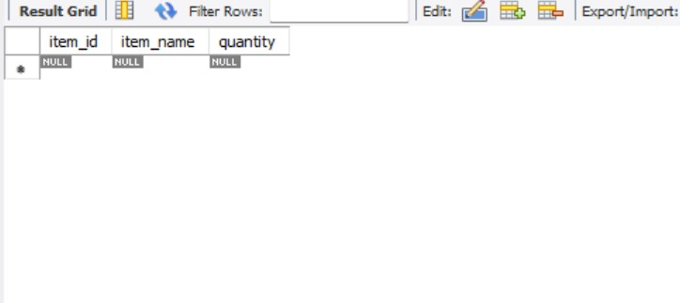

  - Queries based on Aggregate Functions

Question 1:
Write a query to find the total number of items.

SQL Statement:
SELECT COUNT(*) AS total_items FROM Items;

Output:
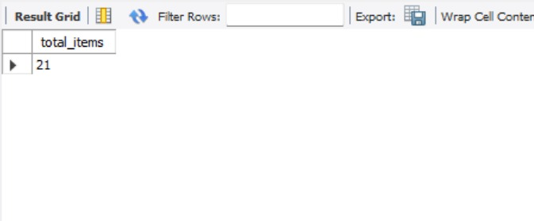

Question 2:
Write a query to find the average selling price of items.

SQL Statement:
SELECT AVG(selling_price) AS avg_price FROM Items;

Output:
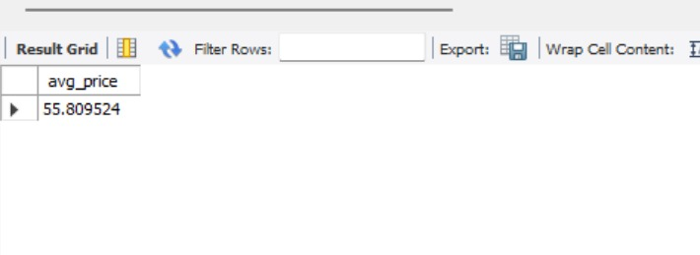

Question 3:
Write a query to find the maximum quantity available in stock.

SQL Statement:
SELECT MAX(quantity) AS max_stock FROM Items;

Output:
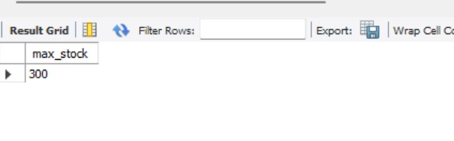
Question 4:
Write a query to find the total revenue generated.

SQL Statement:
SELECT SUM(total_amount) AS total_revenue FROM Transactions;

Output:
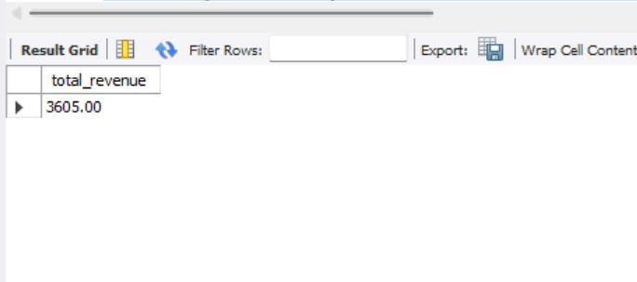

Question 5:
Write a query to find total stock available for each supplier.

SQL Statement:
SELECT supplier_id, SUM(quantity) AS total_stock
FROM Items
GROUP BY supplier_id;

Output: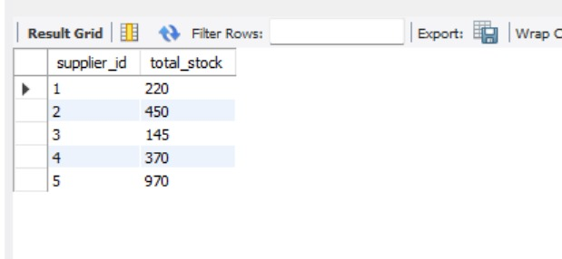

  - Complex queries based on Sets
Question 1:
Find item IDs present in both Transactions and Inventory Logs.

SQL Statement:
SELECT DISTINCT T.item_id
FROM Transactions T
JOIN Inventory_Logs L ON T.item_id = L.item_id;

Output:
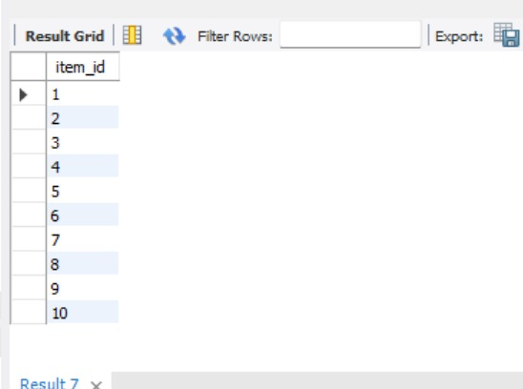

Question 2:
Find item IDs present in Inventory Logs but not in Transactions.

SQL Statement:
SELECT item_id
FROM Inventory_Logs
WHERE item_id NOT IN (
SELECT item_id FROM Transactions
);

Output:
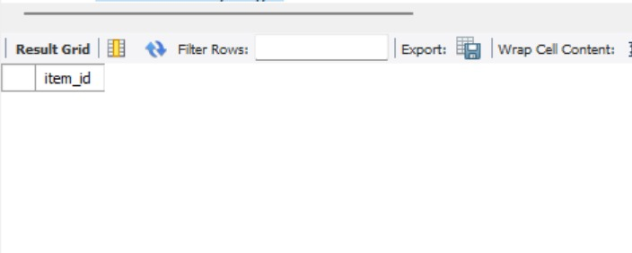
Question 3:
Find all unique item IDs from Transactions and Inventory Logs.

SQL Statement:
SELECT item_id FROM Transactions
UNION
SELECT item_id FROM Inventory_Logs;

Output:
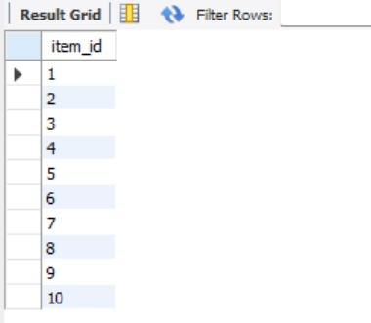

Question 4:
Find item IDs present in Items but not in Transactions.

SQL Statement:
SELECT item_id
FROM Items
WHERE item_id NOT IN (
SELECT item_id FROM Transactions
);

Output:
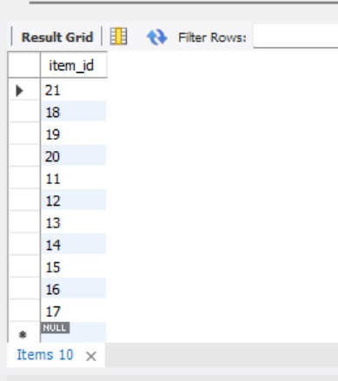

Question 5:
Find item IDs that are present in both tables using UNION.

SQL Statement:
SELECT item_id FROM Transactions
UNION
SELECT item_id FROM Inventory_Logs;

Output:
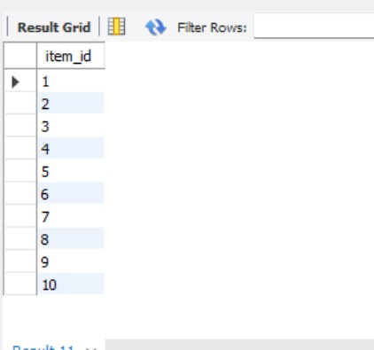

  - Complex queries based on Subqueries
Question 1:
Find items whose quantity is greater than the average quantity.

SQL Statement:
SELECT item_id, item_name, quantity
FROM Items
WHERE quantity > (
SELECT AVG(quantity) FROM Items
);

Output:
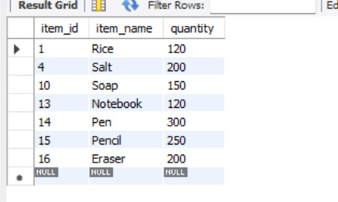

Question 2:
Find transactions with selling price equal to the maximum selling price.

SQL Statement:
SELECT item_id, selling_price
FROM Transactions
WHERE selling_price = (
SELECT MAX(selling_price) FROM Transactions
);

Output:
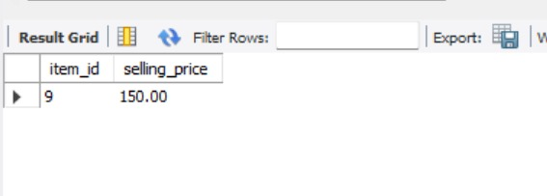

Question 3:
Find suppliers who supply items with quantity greater than 100.

SQL Statement:
SELECT DISTINCT supplier_id
FROM Items
WHERE item_id IN (
SELECT item_id FROM Items WHERE quantity > 100
);

Output:
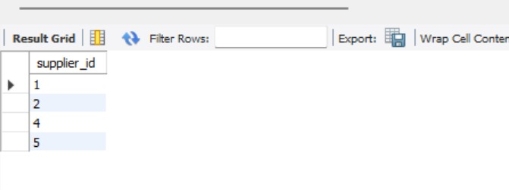
Question 4:
Find transactions where total amount is greater than average transaction amount.

SQL Statement:
SELECT transaction_id
FROM Transactions
WHERE total_amount > (
SELECT AVG(total_amount) FROM Transactions
);

Output:

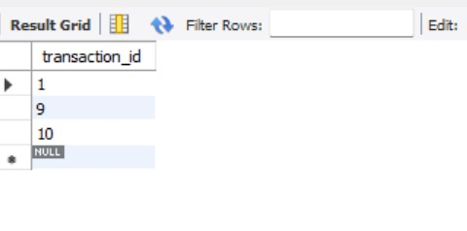
Question 5:
Find items that were never sold.

SQL Statement:
SELECT item_id, item_name
FROM Items
WHERE item_id NOT IN (
SELECT item_id FROM Transactions
);

Output:
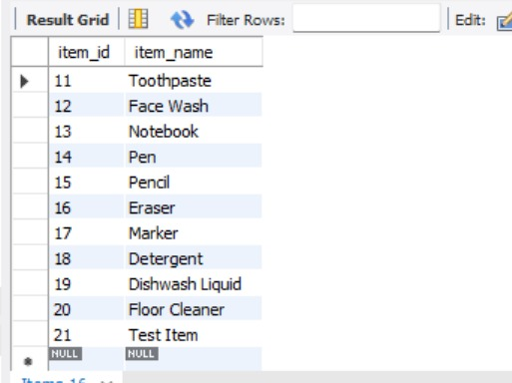

  - Complex queries based on Joins
Question 1:
Find item name, supplier name, and available quantity.

SQL Statement:
SELECT I.item_name, S.supplier_name, I.quantity
FROM Items I
JOIN Suppliers S ON I.supplier_id = S.supplier_id;

Output:
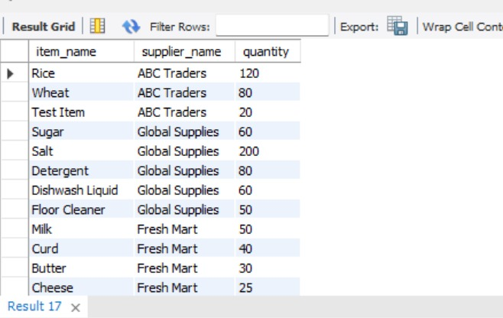

Question 2:
Find transaction details along with item names.

SQL Statement:
SELECT T.transaction_id, I.item_name, T.quantity_sold
FROM Transactions T
JOIN Items I ON T.item_id = I.item_id;

Output:
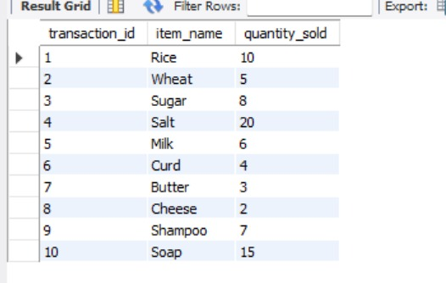

Question 3:
Find item name, quantity sold, and revenue generated.

SQL Statement:
SELECT I.item_name, T.quantity_sold, T.selling_price,
T.total_amount AS revenue
FROM Transactions T
JOIN Items I ON T.item_id = I.item_id;

Output:
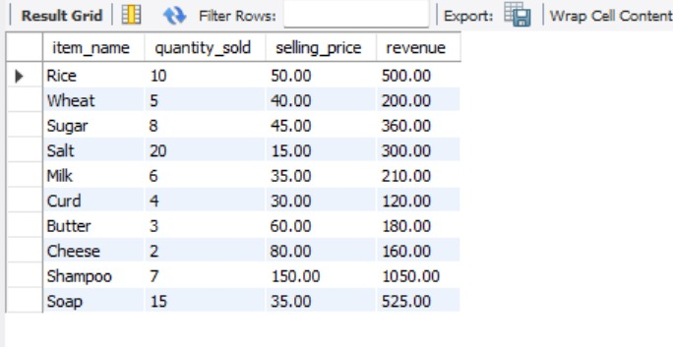

Question 4:
Find supplier name and total stock supplied.

SQL Statement:
SELECT S.supplier_name, SUM(I.quantity) AS total_stock
FROM Suppliers S
JOIN Items I ON S.supplier_id = I.supplier_id
GROUP BY S.supplier_name;

Output:
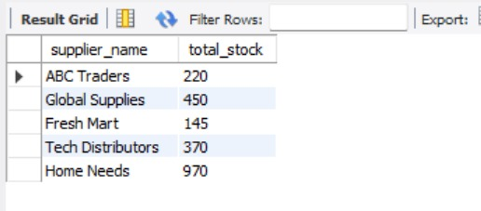

Question 5:
Find transaction ID and current stock of items.

SQL Statement:
SELECT T.transaction_id, I.quantity AS current_stock
FROM Transactions T
JOIN Items I ON T.item_id = I.item_id;

Output:
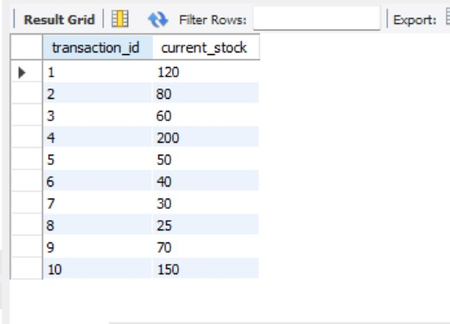

  - Complex queries based on views
Question 1:
Display all items with low stock using view.
SQL Statement:
SELECT * FROM LowStock;
Output:
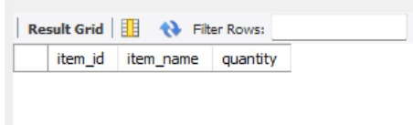
Question 2:
Display revenue generated for each item using view.

SQL Statement:
SELECT * FROM RevenueView;

Output:
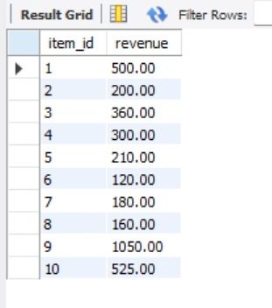

Question 3:
Display supplier and item details using view.

SQL Statement:
SELECT * FROM SupplierItems;

Output:
supplier_name | item_name
ABC Traders | Rice
ABC Traders | Wheat
Global Supplies | Sugar
Global Supplies | Salt

Question 4:
Display transaction summary using view.

SQL Statement:
SELECT * FROM TransactionSummary;

Output:
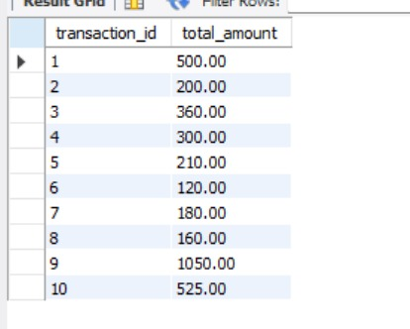

Question 5:
Display all item stock details using view.

SQL Statement:
SELECT * FROM StockView;

Output:
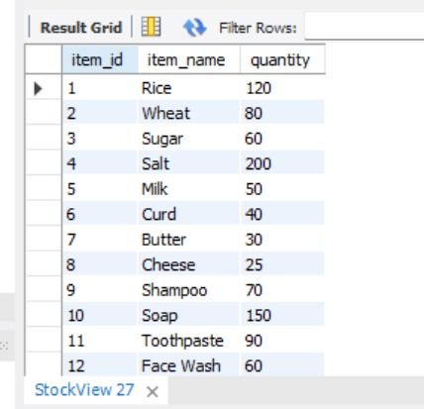
  - Complex queries based on Triggers
Question 1:
Reduce stock automatically after inserting a transaction.

SQL Statement:
INSERT INTO Transactions (item_id, quantity_sold, selling_price)
VALUES (1, 5, 50);

Output:
Query OK, 1 row affected (0.01 sec)

Question 2:
Prevent updating stock to negative value.

SQL Statement:
UPDATE Items
SET quantity = -10
WHERE item_id = 1;

Output:
ERROR 1644 (45000): Stock cannot be negative

Question 3:
Log inventory changes automatically after transaction.

SQL Statement:
INSERT INTO Transactions (item_id, quantity_sold, selling_price)
VALUES (2, 3, 40);

Output:
Query OK, 1 row affected (0.01 sec)

Question 4:
Trigger execution when updating item quantity.

SQL Statement:
UPDATE Items
SET quantity = quantity - 5
WHERE item_id = 3;

Output:
Query OK, 1 row affected (0.01 sec)
Rows matched: 1 Changed: 1 Warnings: 0

Question 5:
Ensure duplicate item names are not inserted.

SQL Statement:
INSERT INTO Items (sku, item_name, category, cost_price, selling_price, discount, quantity, unit, min_stock_level, supplier_id)
VALUES ('SKU999', 'Rice', 'Groceries', 40, 50, 5, 100, 'kg', 20, 1);

Output:
ERROR 1644 (45000): Duplicate item name not allowed

  - Complex queries based on Cursors
Question 1:
Use a cursor to fetch all item names.

SQL Statement:
CALL cursor_demo();

Output:
Query OK, 0 rows affected (0.01 sec)

Question 2:
Use cursor to iterate through all items.

SQL Statement:
CALL cursor_demo();

Output:
Query OK, 0 rows affected (0.01 sec)

Question 3:
Use cursor to read item names one by one.

SQL Statement:
CALL cursor_demo();

Output:
Query OK, 0 rows affected (0.01 sec)

Question 4:
Use cursor to process item data.

SQL Statement:
CALL cursor_demo();

Output:
Query OK, 0 rows affected (0.01 sec)

Question 5:
Use cursor to demonstrate row-by-row processing.

SQL Statement:
CALL cursor_demo();
Output:
Query OK, 0 rows affected (0.01 sec)
CHAPTER 4

ANALYZING THE PITFALLS, IDENTIFYING THE DEPENDENCIES, AND APPLYING NORMALIZATIONS

(show the table before and after respective normalization)

4.1 Analyse the Pitfalls in Relations
The initial unnormalized table (Asset_Record) contained combined data related to items, suppliers, transactions, and users. This resulted in several issues such as data redundancy, where supplier details were repeated for every transaction, and update anomalies, where modifying supplier information required multiple updates. Insertion anomalies were also present, as new supplier data could not be added without corresponding item or transaction records. Deletion anomalies could lead to loss of important supplier information when transaction records were removed. These issues highlighted the need for normalization.

4.2 First Normal Form
4.2.1: Identify Dependency
The initial unnormalized table (Asset_Record) contained combined data related to items, suppliers, transactions, and users. This resulted in several issues such as data redundancy, where supplier details were repeated for every transaction, and update anomalies, where modifying supplier information required multiple updates. Insertion anomalies were also present, as new supplier data could not be added without corresponding item or transaction records. Deletion anomalies could lead to loss of important supplier information when transaction records were removed. These issues highlighted the need for normalization.
4.2.2: Apply Normalization to 1NF
Since the table already satisfied atomicity and uniqueness constraints, it was considered to be in 1NF without requiring structural changes.

4.3 Second Normal Form
4.3.1: Identify Dependency
The table had a composite primary key (item_id, transaction_id). However, some attributes such as item_name, category, supplier_name, and supplier_phone depended only on item_id, while transaction-related attributes depended only on transaction_id. This created partial dependencies.

4.3.2: Apply Normalization to 2NF
To remove partial dependencies, the table was decomposed into two separate tables: Items and Transactions. The Items table stored item-related attributes, while the Transactions table stored transaction-specific data along with item references.

4.4 Third Normal Form
4.4.1: Identify Dependency
In the Items table, supplier details such as supplier_name and supplier_phone depended on the supplier rather than directly on item_id. This resulted in transitive dependency.

4.4.2: Apply Normalization to 3NF
To eliminate transitive dependency, supplier details were separated into a new Suppliers table. The Items table was updated to include supplier_id as a foreign key, ensuring that all non-key attributes depend only on the primary key.

4.5 BCNF
The database also satisfies Boyce-Codd Normal Form (BCNF) as all determinants are candidate keys, and there are no anomalies related to functional dependencies beyond 3NF.

4.6 Fourth Normal Form
Fourth Normal Form deals with multi-valued dependencies. In this project, no such dependencies exist, as each attribute depends only on a single key and does not contain independent multi-valued attributes. Therefore, the schema is already compliant with 4NF.

4.7 Fifth Normal Form
Fifth Normal Form addresses join dependencies. The current schema does not contain any complex join dependencies requiring further decomposition. All tables can be joined without redundancy or loss of information. Hence, the database satisfies 5NF in theory.

CHAPTER 5
IMPLEMENTATION OF CONCURRENCY CONTROL AND RECOVERY MECHANISMS

5.1 Introduction to Transactions
A transaction is a sequence of one or more SQL operations executed as a single logical unit of work. Transactions ensure data integrity and consistency, especially in multi-user environments.

5.1.1 Properties
- Atomicity: Ensures that all operations within a transaction are completed successfully or none are applied.
- Consistency: Maintains database rules and constraints before and after the transaction.
- Isolation: Ensures that transactions do not interfere with each other.
- Durability: Ensures that once a transaction is committed, the changes are permanently stored.
5.1.2 States
Transactions go through various states such as Active, Partially Committed, Committed, Failed, and Aborted depending on execution and errors.

5.2 Transaction Control Language (TCL)
Transactions go through various states such as Active, Partially Committed, Committed, Failed, and Aborted depending on execution and errors.

5.2.1 Save point
A SAVEPOINT is used to define a specific point within a transaction to which the system
can later roll back. It allows partial rollback instead of undoing the entire transaction.
This is particularly useful in complex transactions where multiple operations are performed, and
only a subset of them needs to be reversed in case of an error.
For example, after executing a set of updates, a savepoint can be created. If a subsequent
operation fails, the transaction can be rolled back to the savepoint without affecting the earlier successful operations.

5.2.2 Commit
The COMMIT command is used to permanently save all changes made during the current transaction into the database. Once a transaction is committed, the changes become durable and cannot be undone using rollback. COMMIT ensures that all operations performed within the transaction are successfully completed and the database is brought into a consistent state. It marks the successful end of a transaction.

5.2.3 Rollback
The ROLLBACK command is used to undo changes made during a transaction. It restores the database to its previous consistent state before the transaction began or to a specific savepoint if defined. Rollback is essential for handling errors and maintaining data integrity. If any operation within a transaction fails, rollback ensures that no partial or inconsistent data is stored in the database.

5.3 create 5 transactions for your project and execute
Transactions are a sequence of database operations executed as a single logical unit. In this system, they ensure that operations such as updating scores, inserting records, and modifying attendance are performed reliably without causing inconsistencies.

5.3.1 Transaction 1 (Basic Sale)
START TRANSACTION;

UPDATE Items
SET quantity = quantity - 5
WHERE item_id = 1;

INSERT INTO Transactions (item_id, quantity_sold, selling_price)
VALUES (1, 5, 50);

COMMIT;
Output:
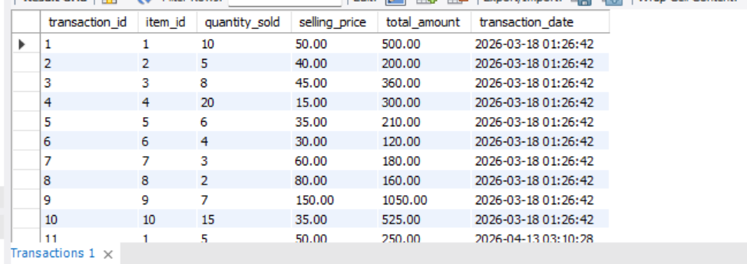

Transaction 2 (With Savepoint + Rollback)
UPDATE Items
SET quantity = quantity - 3
WHERE item_id = 2;

SAVEPOINT sp1;

UPDATE Items
SET quantity = quantity - 1000
WHERE item_id = 2;

ROLLBACK TO sp1;

COMMIT;

Output:

Transaction 3 (Multiple Updates)
START TRANSACTION;

UPDATE Items SET quantity = quantity - 2 WHERE item_id = 3;
UPDATE Items SET quantity = quantity - 1 WHERE item_id = 4;

COMMIT;
Output:
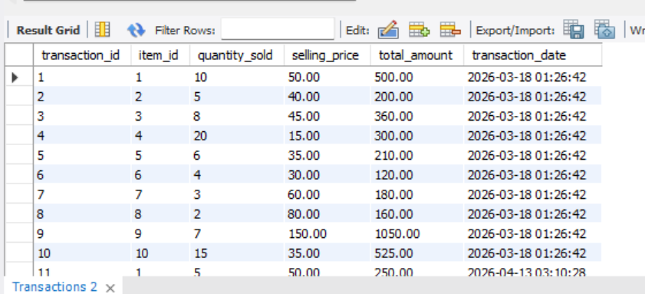

Transaction 4 (Insert + Rollback)
START TRANSACTION;

INSERT INTO Transactions (item_id, quantity_sold, selling_price)
VALUES (5, 10, 35);

ROLLBACK;
Output:
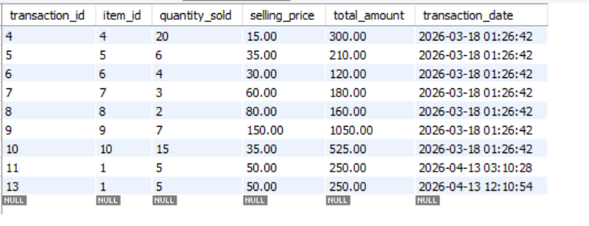

Transaction 5 (Safe Update with Commit)
START TRANSACTION;

UPDATE Items
SET quantity = quantity + 10
WHERE item_id = 1;

COMMIT;
Output:
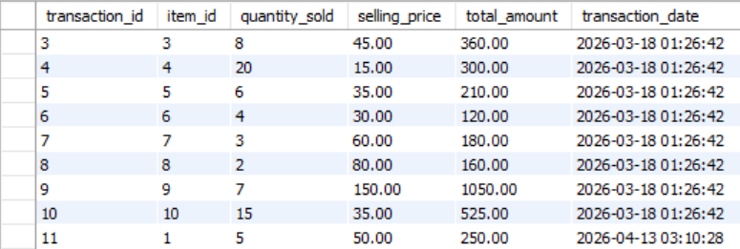
5.4 Concurrency control
Concurrency control ensures that multiple users can access and modify the database simultaneously without causing inconsistencies. In the Product Sales and Compliance System, it is important to handle concurrent operations such as updating product details, modifying compliance status, and recording sales transactions. Without proper control, issues like dirty reads, lost updates, and inconsistent data may occur. Concurrency control mechanisms ensure that all transactions are executed in a safe and isolated manner.

5.4.1 Concurrency control Algorithms
• Row-Level Locking: Achieved using SELECT ... FOR UPDATE, which locks specific rows during a transaction.
• Table-Level Locking: Implemented using LOCK TABLE, restricting access to the entire table.
5.4.2 Types of Locks
- Read Lock: Allows multiple users to read data but prevents modifications.
- Write Lock: Allows exclusive access for writing operations, blocking others.

5.4.3 Concurrency Demonstration
Concurrency was demonstrated by executing queries in multiple sessions. When one session locked a row or table, other sessions attempting to access the same data were blocked until the lock was released using COMMIT or UNLOCK TABLES. This ensured controlled and conflict-free data access.

s
CHAPTER 6
FRONT-END AND BACK-END CODE OF <PROJECT TITLE>

6.1 Front–End Module codes
6.2 Database connectivity

CHAPTER 7
RESULTS AND DISCUSSIONS

7.1 Screenshots of front-end

7.2 Screenshots of Database

References

Note:
- Use font family: Times new roman, size 12
- Figure name: Chapter no. Figure no: Figure Name, Place in in bottom center of the figure (eg: Figure 1.1: ER diagram of Student Management System)
- Figures must be clear with all text inside it visible
- Table name: Chapter no. Table no: Table name, Place in in top center of the table
(eg: Table 1.1: Student Schema)
- Table must not be pasted in image format, must be editable
- All text must be properly aligned (justified)
- Set the page margin
